**Women EmpowermentSystem Team Members**

|  |  |
| --- | --- |
| **Name** | **Role** |
| Vaishali Sharma | Teamlead |
| Malik Rehan Karol | DB lead |
| Nargis Metkari | Controller lead |
| Gauri Deo | UI Lead |
| Shivani Bhavsar | UI Lead |
| Km. Priyanka | UI Lead |
| Satyam | UI Lead |

**Technology Used:**

* Asp.Net Core MVC
* Database-Sql
* EF-DB First Approach, ADO.Net,WebAPI.

**Modules:**

Admin Module

Ngo Module

STEP Module

**Admin Module:**

**Features:**

* Login & Registration
* Dashboard forWomen,Course,NGOs
* Authorize the status for applications.
* Admin Account
* Logout

**NGO Module:**

**Features:**

* Register&Login Module
* Checking the criteria
* Funding Norms
* Adding any training courses
* List of Organizations
* Status of Organizations
* FAQ
* My Account
* Logout

**STEP Module:**

**Features:**

* Register & Login Module
* Checking the Guidelines
* List of Training Courses
* Enrollment for training course
* Status of Enrollment
* List of NGOs
* My Account
* Logout

**DatabaseOverview:**

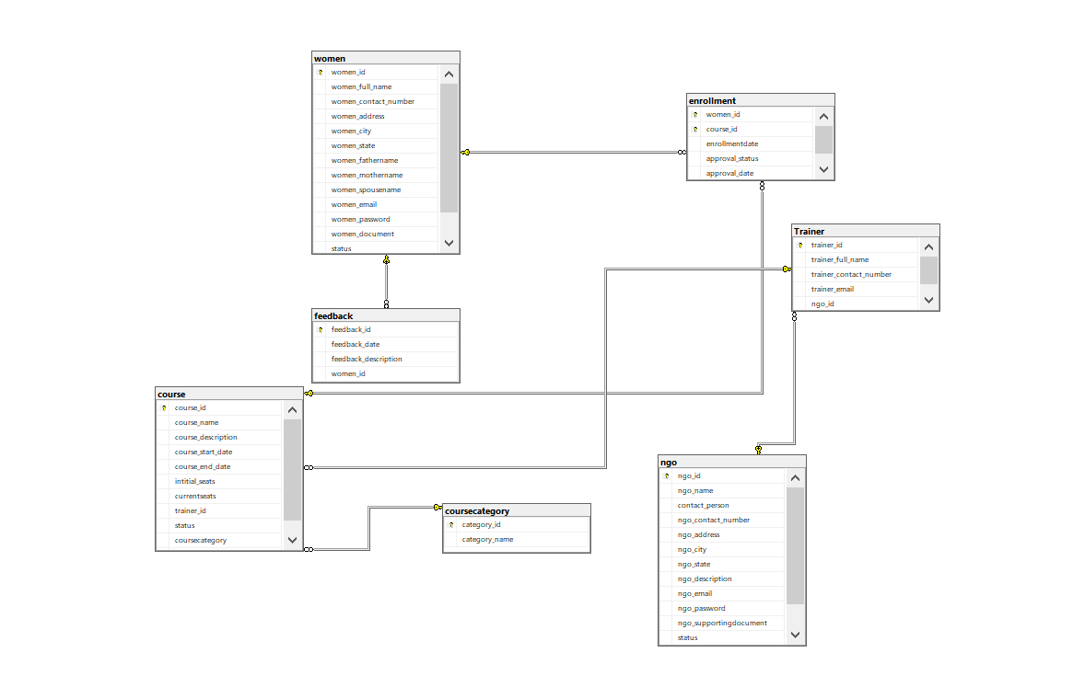

**Project Task Done By Teammates**

|  |  |
| --- | --- |
| **Name** | **Task** |
| Vaishali Sharma | * Implementation Of Admin module * Implementation Of Landing Page * Implementation Of Women, NGO, Courses Dashboard Module * Implementation WebAPI for Project |
| Malik Rehan Karol | * DB Design * Session Concept Implementation * Implementation WebAPI for Project |
| Shivani Bhavsar | * Crud Operation NGOs * NGOs layout * Listing of organization |
| Nargis Metkari | * Implementation of Landing Pages * Login &Register Page for Women Dashboard * Footer Section |
| Gauri Deo | * Content Management * NGOs FAQ * NGOs criteria * Guidelines |
| Satyam | * Implementation of STEP Pages * Register Page for STEP Dashboard * Listing of Course |
| Km. Priyanka | * FAQ Pages * Contact us * Header Section |

**Project Highlights:**

* **Session Concept Implementation for Client Side**

Add Session Service in I configuration service in program.cs and Configured with Pipeline. With Help of Session concept session id will be maintained for 10 minutes.

* Set Session ID in Login module

 HttpContext.Session. SetString ("Username", name) ;)**;**

* GetSessionID

ViewBag.Session = HttpContext.Session. GetString("Username");  
            ViewBag.Session = HttpContext.Session. GetString("id");

* RemoveSession Id in Logout module

HttpContext.Session. Remove("username");

HttpContext.Session. Remove("id");

**Image Add:**

**Code:**

[HttpGet]  
public ActionResult Add()  
{  
return View();  
}

[HttpPost]  
public ActionResult Add(TestImageUploader modal)  
{  
string filename = Path.GetFileNameWithoutExtension(modal.ImageFile.FileName);  
string extension = Path.GetExtension(modal.ImageFile.FileName);  
filename = filename + DateTime.Now.ToString("yymmssfff") + extension;  
modal.imagepath = "~/Assets/" + filename;  
filename = Path.Combine(Server.MapPath("~/Assets/"), filename);  
modal.ImageFile.SaveAs(filename);  
using(FileUploaderEntities db=new FileUploaderEntities())  
{  
db.TestImageUploaders.Add(modal);  
db.SaveChanges();  
}  
ModelState.Clear();  
return View();  
}

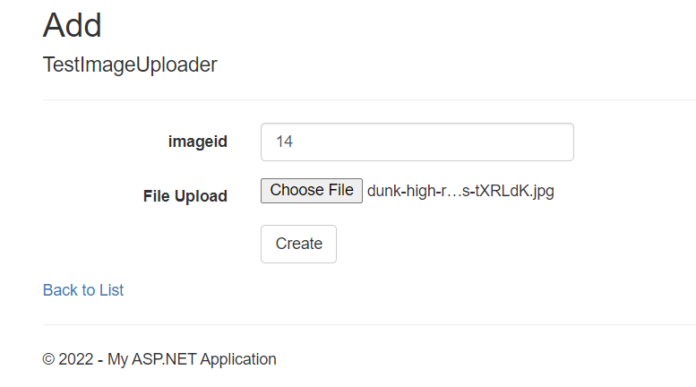

**View Image Code:**

[HttpGet]  
public ActionResult ViewImage(int id)  
{  
TestImageUploader model = new TestImageUploader();  
using(FileUploaderEntities db=new FileUploaderEntities())  
{  
model = db.TestImageUploaders.Where(s => s.imageid == id).FirstOrDefault();  
  
}  
return View(model);  
}

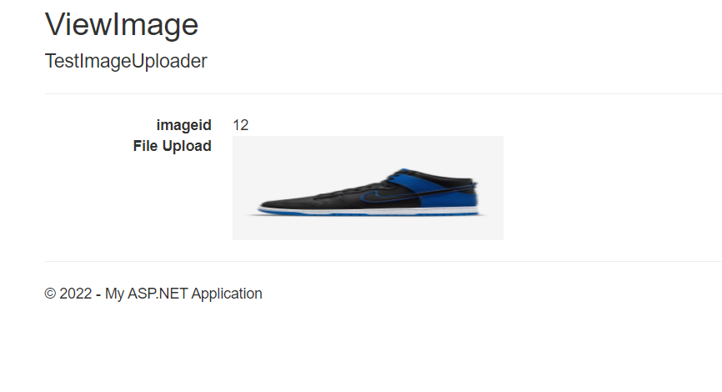

**HomePage:**

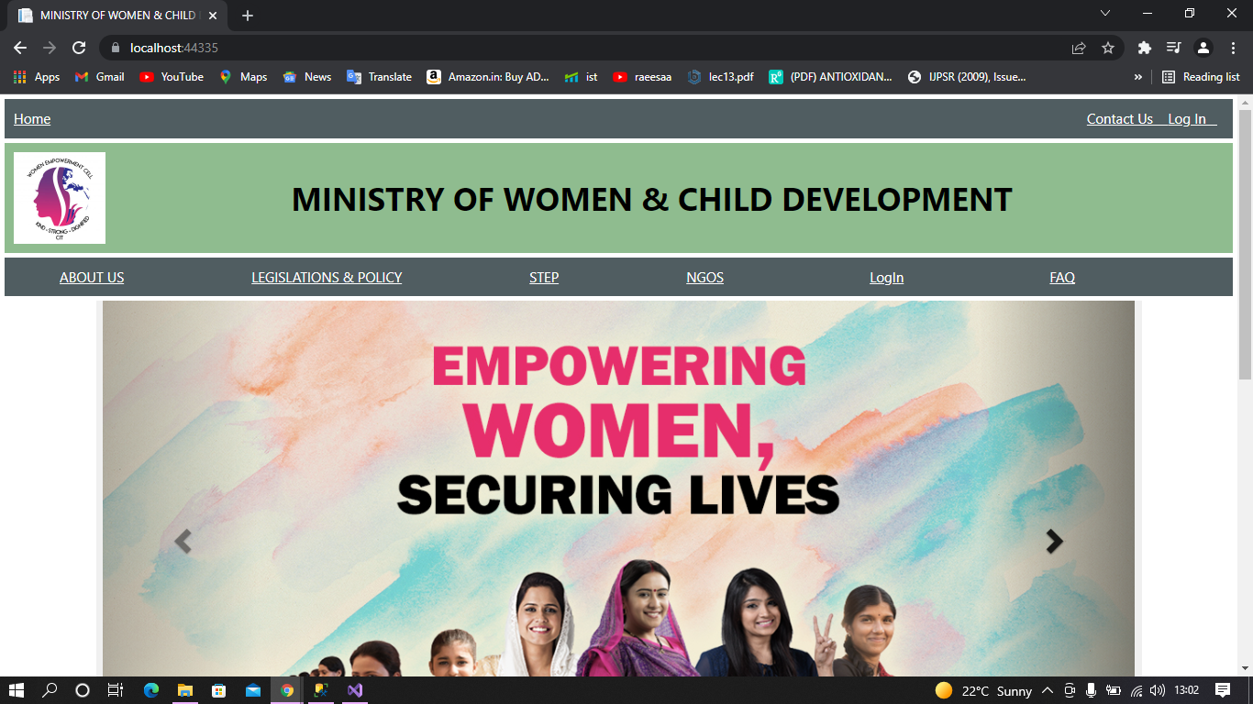

Main Controller Code-

using Microsoft.AspNetCore.Mvc;  
using WomenEmp20Feb.Models;

namespace WomenEmp20Feb.Controllers  
{

    public class MainController: Controller  
 {  
        private readonly WomenEmpowerment21Context db;  
        private ISession Session;

        public MainController (WomenEmpowerment21Context context)  
    {  
            db = context;  
        }  
        public IActionResult Index ()  
        {  
            ViewBag.Session = HttpContext.Session. GetString("Username");  
            return View ();  
        }

        #region Registeration of Women  
        [HttpGet]  
        public IActionResult Register ()  
      {

            return View ();  
      }

        [HttpPost]  
        public IActionResult Register (Woman w)  
        {  
  
                db. Women. Add(w);  
                db. SaveChanges();  
  
  
            ViewBag.message = "Successfully stored";  
            return RedirectToAction ("Login", "Main");

        }

        #endregion

        #region login

        [HttpGet]  
        public IActionResult Login ()  
        {  
            return View ();  
        }

        [HttpPost]  
        public IActionResult Login(Login login)  
        {

            Woman w = new Woman();  
             var user = (from userlist in db.Women where userlist.WomenEmail == login.Email && userlist.WomenPassword == login.Password  
                         select new  
                         {  
                             userlist.WomenId,  
                             userlist.WomenEmail,  
                             userlist.WomenFullName  
                         }).ToList();  
            if (user.FirstOrDefault() != null)  
            {

                return RedirectToAction("Index", "Step");  
            }  
            else  
            {  
                ModelState.AddModelError("", "Invalid login credentials.");  
            }  
  
            return View(login);  
    }

        [HttpGet]  
        public IActionResult Logout ()  
        {  
            HttpContext.Session. Remove("username");  
            return RedirectToAction("Index");  
            TempData["userid"] = null;  
        }

        #endregion

    }  
}

**Main Layout Code: -**

<!DOCTYPE html>

<html>  
<head>  
    <meta charset="utf-8">  
    <meta name="viewport" content="width=device-width, initial-scale=1">  
    <meta name="viewport" content="width=device-width, initial-scale=1.0">  
    <title>MINISTRY OF WOMEN & CHILD DEVELOPMENT</title>  
    @*<link rel="stylesheet" type="text/css" href="style.css"> *@  
    <link rel="stylesheet" type="text/css" href="script.js">  
    <link rel="stylesheet" href="https://maxcdn.bootstrapcdn.com/bootstrap/3.3.7/css/bootstrap.min.css" integrity="sha384-BVYiiSIFeK1dGmJRAkycuHAHRg32OmUcww7on3RYdg4Va+PmSTsz/K68vbdEjh4u" crossorigin="anonymous">  
    <script src="https://maxcdn.bootstrapcdn.com/bootstrap/3.3.7/js/bootstrap.min.js" integrity="sha384-Tc5IQib027qvyjSMfHjOMaLkfuWVxZxUPnCJA7l2mCWNIpG9mGCD8wGNIcPD7Txa" crossorigin="anonymous"></script>  
    <script src="https://ajax.googleapis.com/ajax/libs/jquery/3.5.1/jquery.min.js"></script>  
    <script src="https://maxcdn.bootstrapcdn.com/bootstrap/3.4.1/js/bootstrap.min.js"></script>  
    <link rel="preconnect" href="https://fonts.googleapis.com">  
    <link rel="preconnect" href="https://fonts.gstatic.com" crossorigin>  
    <link href="https://fonts.googleapis.com/css2?family=Overpass:ital,wght@0,100;0,300;1,200&display=swap"  
        rel="stylesheet">  
    <link rel="stylesheet" href="https://cdnjs.cloudflare.com/ajax/libs/font-awesome/4.7.0/css/font-awesome.min.css">  
   <meta charset="utf-8" />  
    <meta name="viewport" content="width=device-width, initial-scale=1.0" />  
    <title>@ViewData["Title"] - WomenEmp20Feb</title>  
    <link rel="stylesheet" href="~/lib/bootstrap/dist/css/bootstrap.min.css" />  
    <link rel="stylesheet" href="~/css/style.css" asp-append-version="true" />  
    <link rel="stylesheet" href="~/WomenEmp20Feb.styles.css" asp-append-version="true" />  
</head>  
<body>  
    <!-- Start of Header Links-->  
    <div class="main-div-border">  
        <div class="div1">  
            <a class="heading" asp-area=" asp-controller="Home" asp-action="Index">Home</a>  
  
            @if(ViewBag.Session==null)  
            {  
                <a class="heading" asp-area="" asp-controller="Main" asp-action="Login" style="float: right; padding-right: 7px;"> Log In &nbsp&nbsp</a>  
            }

            else{  
             <a class="heading" asp-area="" asp-controller="Home" asp-action="Index" style="float: right; padding-right: 7px;"> Log Out &nbsp&nbsp</a>  
            }  
             <a class="heading" asp-area="" asp-controller="Home" asp-action="ContactUs" style="float: right;">Contact Us &nbsp &nbsp</a>  
        </div>  
        <div class="div2">  
  
            <img src="~/images/logo.jpg"  class="logo">  
            <p class="MWCDtitle">MINISTRY OF WOMEN & CHILD DEVELOPMENT</p>  
        </div>  
        <div class="menu-div">  
            <a class="menu-div" style="margin-right: 110px; margin-left: 40px;" asp-area="" asp-controller="Home" asp-action="AboutUs">ABOUT US</a>  
            <a  class="menu-div" style="margin-right: 110px;" asp-area="" asp-controller="Home" asp-action="Legislation">LEGISLATIONS & POLICY</a>  
            <a class="menu-div" style="margin-right: 110px;" asp-area="" asp-controller="Step" asp-action="Index">STEP</a>  
            <a class="menu-div"  style="margin-right: 130px;" asp-area="" asp-controller="NGO" asp-action="Index">NGOS</a>  
            <a class="menu-div"  style="margin-right: 130px;" asp-area="" asp-controller="Main" asp-action="Login">LogIn</a>  
            <a class="menu-div"  asp-area="" asp-controller="Home" asp-action="FAQ">FAQ</a>  
        </div>  
    </div>  
    <!-- End of Header Links-->

    <div>  
        @RenderBody ()  
    </div>

    <!-- Site footer -->  
    <footer class="site-footer">  
        <div class="container">  
            <div class="row">  
                <div class="col-sm-12 col-md-6">  
                    <h6 class="hover-underline-animation">About</h6>  
                    <p class="text-justify">MINISTRY OF WOMEN & CHILD DEVELOPMENT is an organization, has been active for over 2 years helping the women to  
                        become self independent.  
                        We help them to grow and learn new skills. Our current focus is on the development of women in rural areas  
                        with a vision to expand the services of the center, and create more such options in other parts of the  
                        country.</p>  
                </div>  
  
                <div class="col-xs-6 col-md-3 ">  
                <h6 class="hover-underline-animation">Contact Us</h6>  
                <br>  
                <p><span class="glyphicon glyphicon-map-marker"></span> Pune, Maharashtra</p>  
                <p><span class="glyphicon glyphicon-phone"></span> +91 9898989898</p>  
                <p><span class="glyphicon glyphicon-envelope"></span> mwcd@gmail.com</p>  
  
  
                </div>  
  
                <div class="col-xs-6 col-md-3">  
                    <h6 class="hover-underline-animation">Quick Links</h6>  
                    <ul class="footer-links">  
                        <li><a asp-area="" asp-controller="Home" asp-action="AboutUs">About Us</a></li>  
                        <li><a asp-area="" asp-controller="Home" asp-action="ContactUs">Contact Us</a></li>  
                        <li><a asp-area="" asp-controller="STEP" asp-action="Index">STEP</a></li>  
                        <li><a asp-area="" asp-controller="NGO" asp-action="Index">NGO</a></li>  
                        <li><a asp-area="" asp-controller="Home" asp-action="FAQ">FAQ</a></li>  
                    </ul>  
                </div>  
            </div>  
            <hr>  
        </div>  
        <div class="container">  
            <div class="row">  
                <div class="col-md-8 col-sm-6 col-xs-12">  
                    <p class="copyright-text">Copyright &copy; 2022 .Net Batch  
                        <a href="#">Team 1</a>.  
                    </p>  
                </div>  
  
                <div class="col-md-4 col-sm-6 col-xs-12">  
                    <ul class="social-icons">  
                        <li><a class="facebook" href="https://www.facebook.com/" target="_blank"><i class="fa fa-facebook"></i></a></li>  
                        <li><a class="twitter" href="https://www.twitter.com/" target="_blank"><i class="fa fa-twitter"></i></a></li>  
                        <li><a class="dribbble" href="https://www.instagram.com/" target="_blank"><i class="fa fa-instagram"></i></a></li>  
                        <li><a class="linkedin" href="https://www.linkedin.com/" target="_blank"><i class="fa fa-linkedin"></i></a></li>  
                    </ul>  
                </div>  
            </div>  
        </div>  
    </footer>  
     <script src="~/lib/jquery/dist/jquery.min.js"></script>  
    <script src="~/lib/bootstrap/dist/js/bootstrap.bundle.min.js"></script>  
    <script src="~/js/site.js" asp-append-version="true"></script>  
    @await RenderSectionAsync("Scripts", required: false)  
</body>  
</html>

**Index Page-**

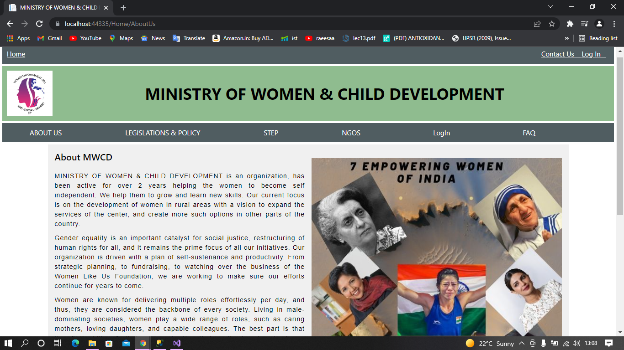

**Women Registration Page: -**

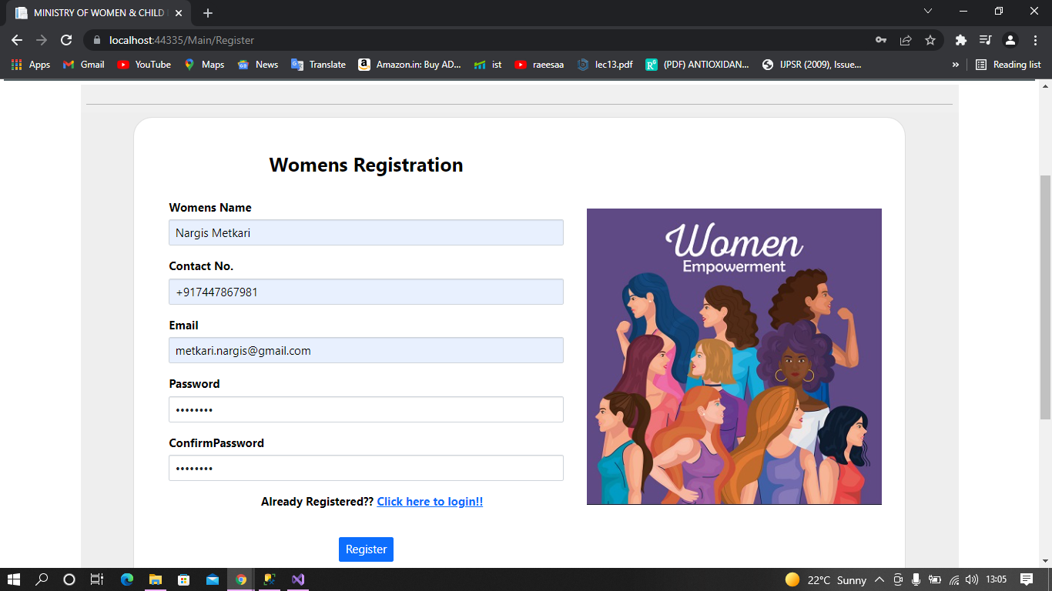

**Women Login Page: -**

